**Project Documentation**

**Basketball Player Manager**

**Members:**

**Mateo Rada Arias**

**Jhorman Germán Mera Escobar**

**Paula Andrea Trujillo Mejía**

**Nicolas Gómez Botero**

**Course:**

**Algorithms and Data Structures**

**Docent:**

**Juan Manuel Reyes García**

**Icesi University**

**Cali - Valle del Cauca**

**02 November 2021**

**Functional Requirements**

The program must be able to:

1. **Req1. Implement** a tool for handling large information that allows data to be entered, either in bulk (with .csv files) or through an interface.
2. **Req2. Delete** data.
3. **Req3. Modify** data.
4. **Req4. Search** for data.
5. **Req5. Make** player queries using the statistical categories included as search criteria.
6. **Req6. Include** the following items to the data associated with each player: name, age, team and 5 statistics.
7. **Req7. Recover** players according to the selected search category and the value given for it
8. **Req8. Use** balanced binary search trees to quickly access player data so that the search takes O (log n) time for those that have associated indexes.
9. **Req9. Show** the time it takes to make a query.
10. **Req10. Allow** the customer to search on two statistical criteria using ABB as a framework for index management.

**Class Diagram**

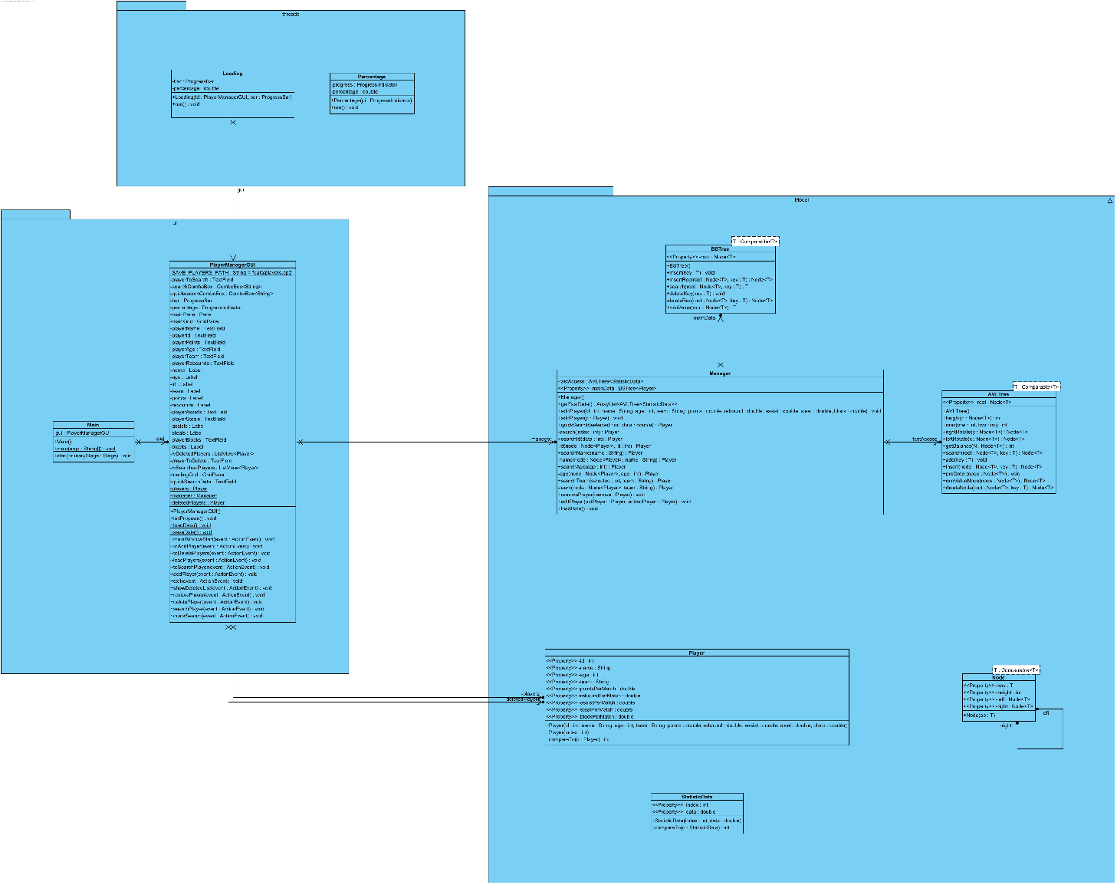

*To see the class diagram of the model with a better quality, please refer to the end of the document*.

**Unit Test Class Diagram**

*To see the unit test class diagram in a better quality, go to the end of the document*

*of the document*

**AVL Unit Test Design**

|  |  |  |
| --- | --- | --- |
| **Name** | **Class** | **Scenary** |
| **setupScenary1** |  |  |
|  |  |  |
|  |  |  |
|  |  |  |
|  |  |  |
|  |  |  |
|  |  |  |

**AVL Test Case Design**

|  |  |  |  |  |
| --- | --- | --- | --- | --- |
| **Test objective** | | | | |
| **Class** | **Method** | **Scenary** | **Input Values** | **Result** |
|  |  |  |  |  |

**BST Unit Test Design**

|  |  |  |
| --- | --- | --- |
| **Name** | **Class** | **Scenary** |
| **setupScenary1** |  |  |
|  |  |  |
|  |  |  |
|  |  |  |
|  |  |  |
|  |  |  |
|  |  |  |

**BST Test Case Design**

|  |  |  |  |  |
| --- | --- | --- | --- | --- |
| **Test objective** | | | | |
| **Class** | **Method** | **Scenary** | **Input Values** | **Result** |
|  |  |  |  |  |

**Model Unit Test Design**

|  |  |  |
| --- | --- | --- |
| **Name** | **Class** | **Scenary** |
| **setupScenary1** |  |  |
|  |  |  |
|  |  |  |
|  |  |  |
|  |  |  |
|  |  |  |
|  |  |  |

**Model Test Case Design**

|  |  |  |  |  |
| --- | --- | --- | --- | --- |
| **Test objective** | | | | |
| **Class** | **Method** | **Scenary** | **Input Values** | **Result** |
|  |  |  |  |  |